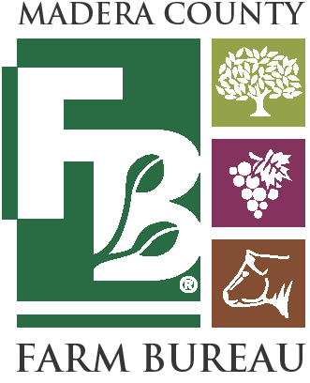
Annual Scholarship Event
Margaritas and Lunch
at the Mahils’
Sunday, May 4, 2025  11:00 a.m. - 2:00p.m.
Mahil Residence – 8808 Road 30, Madera, CA 93637

SPONSOR/TICKET ORDER FORM

FAX to (559) 674-0529 or EMAIL office@maderafb.com by: Friday, March 21, 2025

Contact information________________________________________________ ____
Business Name: __________________________________________________________________________________
Contact Person: Title:
_______________________________________________ _______________________________________
Mailing Address: City: State: Zip:
_____________________________ ___________________ _______ ___________________
Phone: Fax: Email:
_________________________ __________________________ ___________________________

Sponsorship/Tickets_______________________________________________________ _
Levels of Participation-Please CHECK DESIRED LEVEL OF PARTICIPATION

( ) $3,000 - Lead Vineyard Sponsorship Level
Sponsors will be featured on: Company Logo on Event Tickets, Social Media, Local and MCFB Farm Bureau Newspapers, Website and Event Program. Includes 4 event tickets.

( ) $1,500 - Private Reserve Level
Sponsors will be featured on: Company Name on Tickets, MCFB Newspaper & Social Media, Website, and Event Program. Includes 2 event tickets.

( ) $500 - Barrel Select Level
Sponsors will be featured on: Website, Social Media, and Event Program.

( ) Other Donation Amount

( ) $70 – Tickets Only
Attendees will have unlimited access to margaritas and lunch.

Please mail and make checks payable to: Madera County Farm Bureau
Scholarship Fund
1102 South Pine Street
Madera, CA 93637

For additional information, please contact Christina Beckstead at (559) 674-8871
More information available at: www.maderafb.com

